Semantically Enhanced Medical Information Retrieval System: A Tensor Factorization Based Approach

With the exponential growth of medical related informa- tion, the retrieval of high quality results is becoming more critical. For medical applications like the Clinical Decision Support System (CDSS), an effective and reliable informa- tion retrieval (IR) system is the basis to provide scientific evidences to support the clinical decision making, facilitate the translation of latest research outcomes into practice and improve the quality of health care [1]. The challenges are from (a) the inherent complexity of medical languages such as obscure medical terminologies and ambiguous abbreviations, and (b) the associated variety of information needs from different types of users, such as patients and physicians [2]. The complexity and ambiguity of medical languages result in vocabulary mismatch between queries and documents, which makes the conventional keyword-based IR methods often ineffective in medical IR tasks. Semantic knowledge bases and concept mapping techniques are with the potential to solve this problem through annotating and analyzing the information with a common medical terminology and seman- tic relations including the classifications, term dependencies, hierarchies, etc. Integrating the semantic relations is able to access and use the rich information of domain knowledge to enable accu- rate inferences for varying information needs. Ontologies and associated semantic information are useful resources to extract structured knowledge for IR. For instance, a user sub- mits a query to search for the information of fever treatment. There is a document introducing ‘‘aspirin’’, a medication used to treat fever. Human experts may judge that this doc- ument is relevant to the user’s query. However, this relevance could not be automatically identified without the knowledge bases which contain the association in the form of a triple (‘‘aspirin’’, ‘‘may_treat’’, ‘‘fever’’). Studies also showed that the proper incorporation of semantic information in knowledge bases is critical to the performance of medical IR [3]. One of the most effective approaches is knowledge-based query expansion, which is a well-known method to bridge the gap between query terms and actual user information needs [4]. With the expanded set of terms, there is a higher probability to identify and retrieve relevant documents that do not contain the terms in the original query. In addition, query expansion is flexible to be integrated with existing IR systems. However, there are a number of problems that need to be addressed when we incorporate the semantic information in knowledge bases: (a) Most medical knowledge databases suf- fer from the incompleteness and lack of reasoning capability over relations [5]; (b) The noisy samples and the inaccuracy of concept mapping set higher requirement for the model to achieve good performance. For instance, a study showed that the precision of concept mapping through MetaMap is only 71.8% [6]; (c) Similar to many real-world datasets, the observed data is generally sparse because of the incomplete- ness of knowledge bases and the limited annotated samples. Therefore, there is a crucial need to develop a systematic methodology to address the aforementioned problems, and effectively incorporate the semantic knowledge bases for medical IR. To address these challenges, we developed a semantically enhanced medical IR system based on a two-stage query expansion strategy. The system first expanded the origi- nal query through incorporating new terms from initially retrieved documents. Then, we proposed a latent semantic rel- evance model for the system to capture the relevant concepts and semantic relations between concepts through extracting semantic triples from knowledge bases. The system built the third-order tensor to represent the ternary relations, and adapted tensor factorization methods to estimate the latent features of the semantic association triples. Advantages of the proposed tensor factorization based latent feature model are summarized as follows: (a) the incompleteness problem can be formed as filling in missing entries in relational datasets. Tensor factorization is widely used for this kind of prob- lems such as link prediction [7]. (b) Multi-way analysis is more robust to noise over two-way matrix analysis bene- fiting from the power of multi-liner algebra [8]. (c) Tensor factorization provides the unique capability to work well under sparse settings such as recommender systems [9]–[11]. Tensor factorizations have been demonstrated to be an effective way to resolve the sparsity problem by breaking the independence of multiple interaction parameters [12]. Based on the proposed latent semantic relevance model, we identified effective semantic patterns to trigger knowledge- based query expansion. Our system is able to incorporate medical knowledge bases to infer the actual user needs and improve the performance of medical IR tasks. Experiments with the TREC CDS 2014 dataset demonstrate that the per- formance of the proposed system is significantly better than the baseline and the best results reported in TREC CDS 2014 conference, and is comparable with state-of-the-art approaches on this retrieval task. The rest of this paper is organized as follows. Section II summarizes related work on semantic IR and tensor factoriza- tion based applications. Section III introduces notations and preliminaries. The proposed medical IR system is presented in Section IV. Experiment results are evaluated in Section V. We conclude the paper in Section VI with discussions of future work.

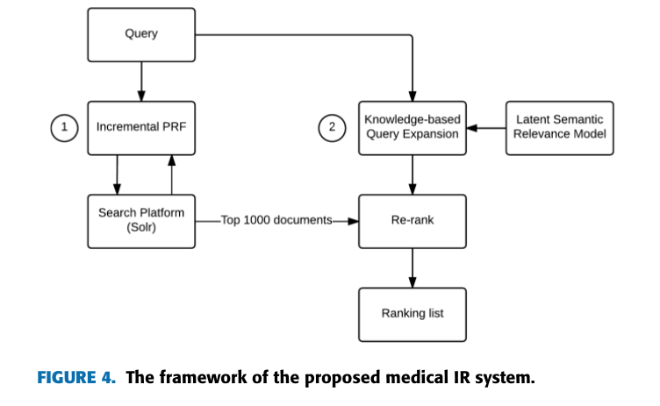
We developed a semantically enhanced medical IR system, which has a two-stage query expansion strategy (as shown in Figure 4) to integrate the pseudo relevance feedback and the knowledge-based query expansion to improve the performance of retrieving relevant documents for queries. In general, relevance feedback is to statistically discover the implicit relevant information to improve the recall of retrieved documents, while knowledge-based query expan- sion is to infer a user’s actual needs with domain knowledge to improve the precision. First, we proposed the incremental pseudo relevance feedback (incremental PRF) approach for query expansion to obtain the initial ranking list of retrieved documents. Second, we developed an enhanced knowledge- based query expansion method with a novel latent seman- tic relevance model. The proposed method will re-rank the documents retrieved by the incremental PRF in the first stage. For instance, when a user input a query, the system will first (a) use incremental PRF to expand the query and obtain the top 1000 relevant documents based on the search platform (Solr). Then, the system will (b) use the proposed latent semantic relevance model to expand the query based on medical knowledge bases. In the end, the system will (c) use the expanded query based on knowledge to re-rank the 1000 relevant documents as the final retrieval result.

Improve Biomedical Information Retrieval Using Modified Learning to Rank Methods

In recent increased years, exponentially, research articles which in biomedicine makes it difficult domain for biologists to manually capture all the information they need. To meet biologists’ information need better, information retrieval (IR) techniques designed for biomedicine domain have been addressed, focusing on how to effectively retrieve the needed information. Given a query, an IR system can search for its relevant documents, and rank the documents based on their relevance degrees to the query. Unlike tradi- tional IR, biomedical IR faces some domain specific chal- lenges, most of which are due to the abundance of the terminologies. Different articles may use different terminolo- gies to represent the same concept, and as a result, two rele- vant documents for the same query may vary a lot. To meet the information need more completely, biomedical IR system should cover the relevance documents from different aspects, where an aspect of relevance documents refers to a subset of relevant documents related to the same terminologies. Therefore, biomedical retrieval systems not only focus on obtaining the most relevant documents to a given query, but also emphasize the query-related aspects coverage in the doc- ument ranked list, which is mostly denoted as the diversity of the searching result. To explain the diversity further, consider an example of a biomedical query “What is the role of MMS2 (a kind of enzyme) in cancer?”. Given the query, we retrieve its relevant documents based on their closeness to the query, and then relevant documents are divided into multiple groups. Each group has a unique label, such as “cell differ- entiation”, “DNA repair”, “DNA damage”, each reflecting one aspect of the query. All the query aspects covered in the document ranking list indicate the diversity degree of the results. Our searching goal is to retrieve the most relevant documents covering as many aspects as possible. In recent years, various traditional IR models have been introduced for the biomedical document ranking, and achieve some good results. Learning to rank, as a state-of-the-art IR technique, has been proved effective in many IR tasks, which solves ranking problems using machine learning methods with various features, and many learning to rank methods have been proposed [1], [2], [3], [4], [5], [6], [7], [8]. However, few studies attempted to employ learning to rank methods to improve the diversity oriented biomedical information retrieval. Learning to rank methods have some advantages over other traditional IR models. For one thing, it can make the most of various ranking information comprehensively to construct a ranking model. The ranking information can be either statistical textual features, such as term frequency, or some features obtained from traditional IR models, such as vector space model. For another, the training phase for learn- ing to rank methods iteratively reduce the value of ranking loss (i.e., the difference between the predicted ranking and the ground truth ranking) until eventually an optimal ranking model is obtained. Therefore, it seems promising to improve biomedical retrieval using learning to rank methods. In the paper, we propose a novel framework based on learning to rank methods to study whether learning to rank

methods would benefit biomedical retrieval and boost both the relevance and the diversity of results. In the framework, we propose two novel labeling strategies to capture the aspect information of the relevant documents, thus forming the ground truth document labels. Meanwhile, we represent the documents to a given query as feature vectors by scoring the documents using different traditional IR models. Then, we construct an effective ranking model using these feature vectors as training data to improve retrieval performance. Finally, for a new query, we predict its corresponding docu- ment ranking using the trained model. The contributions of the paper are listed as follows: 1) we propose a learning framework to integrate learn- ing to rank methods into biomedical information retrieval, and compare the performance of several state-of-the-art learning to rank methods in this framework;
2) we propose two labeling strategies: one is focusing on constructing an optimal ranking target, and the other is based on the group-wise learning to rank method;
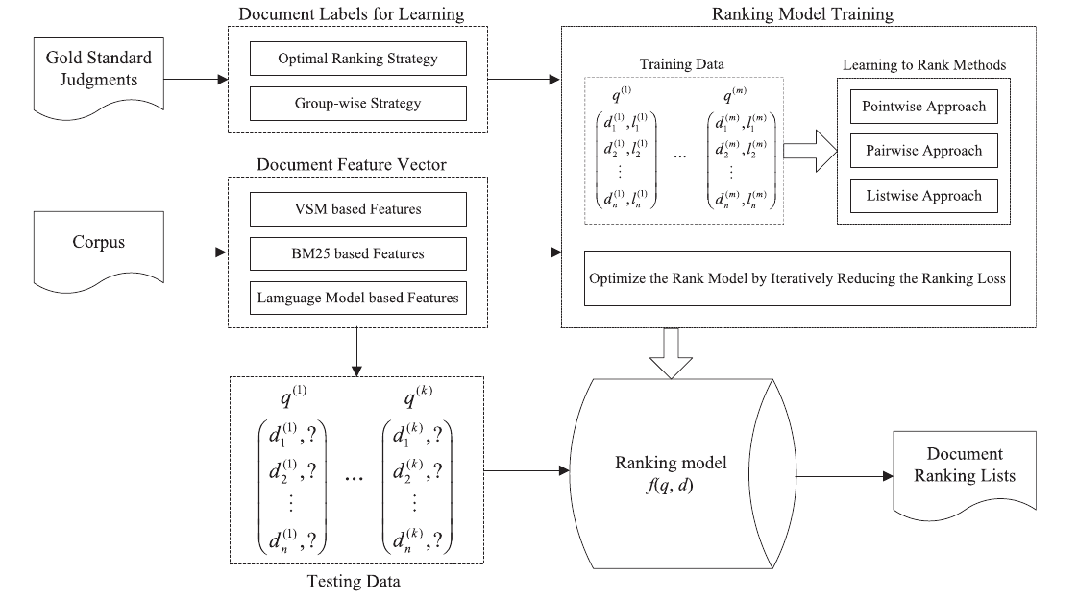
3) we examine the effectiveness of the proposed frame- work on TREC Genomics Track datasets, and com- pare the performance of different learning to rank methods for our framework.

Biomedical Information Retrieval
Introduction
Thousands of articles are being added into biomedical literature each year and this large collection of publications offer an excellent opportunity for discovering hidden biomedical knowledge by applying information retrieval (IR) and Natural Language Processing (NLP) technologies.
The recent statistics shows that 70% of total web search queries are of medical and healthcare category. Biomedical Information Retrieval(BIR) is a special type of information retrieval.

Literature survey
Major challenges in biomedical information retrieval are in handling complex, ambiguous medical terms and their ad-hoc abbreviations. The average length of biomedical entities is much higher than general entities. Identifying such medical entities is a preliminary subtask. Physicians use ad-hoc abbreviations very frequently and they are ambiguous like ’PSA’ can be ’prostate specific antigen’ or ’poultry science association’. Such different different representations of the same entity should be normalized to a single representation. This problem is known as entity normalization
There can be two types of users of the healthcare related search systems : experts(clinicians) and laymen(other than clinicians). The query formulations of both the users are different for the same information need. For example, general people use the words ’heart attack’, ’Irregular heartbeat’, while experts use the words ’Myocardial infarction’,’Cardiac arrhythmia’, respectively.
This leads to the problem of vocabulary mismatch where different people name the same thing or concept differently. Missing synonyms causes low retrieval recall i.e. out of all relevant documents in the collection, very few relevant documents get retrieved. Also, ambiguous terms cause low precision i.e. out of all retrieved documents, very few are relevant.
PubMed is a biomedical search engine which accesses primarily the MEDLINE database of abstracts and references on biomedical topics and life sciences and is maintained by the United States National Library of Medicine (NLM)1 at the National Institutes of Health (NIH). PubMed does binary matching[15] and is useful for short queries only.
On the contrary medical and healthcare related queries are longer than general queries since people used to describe the symptoms, tests and ongoing treatments. For verbose and longer queries, biomedical IR systems should deal properly with ambiguous, complex and inconsistent biomedical terminologies which is difficult to handle. synonymy.
Automatic query expansion (AQE) [11], [4] which has a long history in information retrieval can be useful to deal with such problems.
Query Expansion which uses the top retrieved relevant documents is known as Relevance Feedback since it uses the human judgement to identify the relevancy.

PRF

Pseudo Relevance Feedback technique assumes the top retrieved documents relevant and uses as feedback documents. Table 1 shows the results of standard retrieval, Pseudo-Relevance Feedback (PRF) based Query Expansion and Relevance Feedback (RF) based Query Expansion with BM25 [1] and In_expC2 [1] retrieval models. Terrier tool has been used for all these experiments. MAP and infNDCG are used as evaluation metrics [10]. Higher the value of evaluation measure, better the retrieval result of system. The result improves when Query expansion is used. PRF based query expansion and RF based query expansion give statistically significant results as compared to no expansion.

Automatic query expansion methods based on pseudo relevance feedback uses top retrieved documents as feedback documents.[10] [4] Those feedback documents might not be all relevant. The feedback document set might contain non-relevant docs along with truly relevant documents. The retrieval system gets harm with these non-relevant documents in feedback set. They are like noise in the feedback system. One attempt is to learn the truly relevant documents for feedback by using minimum human intervention. The approach uses human judgements for a small set of feedback documents and then it tries to learn identifying true relevant documents from rest of the documents. Then the documents identified relevant are used for feedback and query expansion is performed. Two approaches for this learning based on classification and clustering are presented here. First Algorithm: The first proposed algorithm is based on classification. If we have human judgements available for some of the feedback documents, then it will serve as a training data for classification. The documents are represented as a collection of bag-of-words, the TF-IDF scores of the words represent features and human relevance scores provides the classes. By using this as a training data, we want to predict the relevance of other top retrieved feedback documents.

and it is responsible for insignificant improvement. This approach further removes non-relevant documents from relevant document class identified by classification approach. The idea is to perform clustering on the relevant identified documents with number of clusters two: one from actually relevant documents and second from non-relevant documents.

The experiments are performed using nine different classifiers for classification in first algorithm. The table 2 shows the results in terms of MAP score for CDS 2014 dataset. Neural-Net gives best result among all nine classifiers. Also, the result of classification with Nearest-Neighbors is comparable to the baseline.

For all the 30 queries of CDS 2014, classification Nearest-Neighbours classified 625 documents as relevant out of all 200*30 documents. Out of 625 documents used for feedback, 244 documents were actually relevant while other 381 documents were wrongly classified as relevant. So, these 381 irrelevant documents are noise to the system. The second approach takes this matter into consideration and further refine the feedback document set by performing 2-cluster clustering on 625 documents. Manually removing 381 irrelevant documents from feedback document set shows significant improvement over baseline.

